**Lesson 6**

**Topic:** Creating Basic Visualizations & Adding Interactivity to Visuals  
**Prerequisites:** Download Sales_Interactive.xlsx file.

**1. Name three types of visuals you can create in Power BI**

* **Bar Chart (horizontal bars)**
* **Column Chart (vertical bars)**
* **Line Chart (trend over time)**

**2. How do you add a slicer to a report?**

* In the **Visualizations** pane, we select the **Slicer** icon.
* Drag a field (e.g., Quarter) into the slicer.
* The slicer will filter all visuals on the page.

**3. What is the difference between a bar chart and a column chart?**

* **Bar chart** → horizontal bars, better for long category names.
* **Column chart** → vertical bars, better for time-series or sequential data.

**4. How do you change the color of a visual background?**

* Select the visual.
* Go to the **Format (paint roller)** pane → **Background** → choose a color and adjust transparency.

**5. What does "drill-down" mean in a visual?**

**Drill-down** means navigating deeper into the data hierarchy.  
Example: First you see sales by **Region**, then by clicking you can “drill down” into **Product**, and then into **Quarter**.

**6. Create a bar chart showing SalesAmount by Region**

* Drag Region to Axis.
* Drag SalesAmount to Values.
* Choose **Bar Chart** from Visualizations.

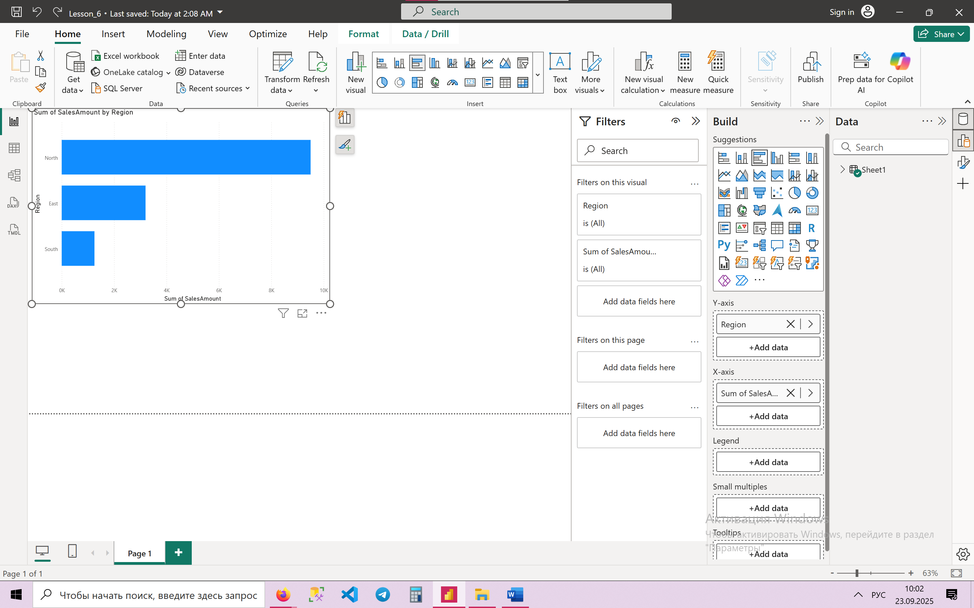

**7. Add a slicer for Quarter to filter all visuals on the page**

* Insert a **Slicer** visual.
* Drag Quarter into the slicer field.
* Then selecting Q1 or Q2 will filter all visuals.

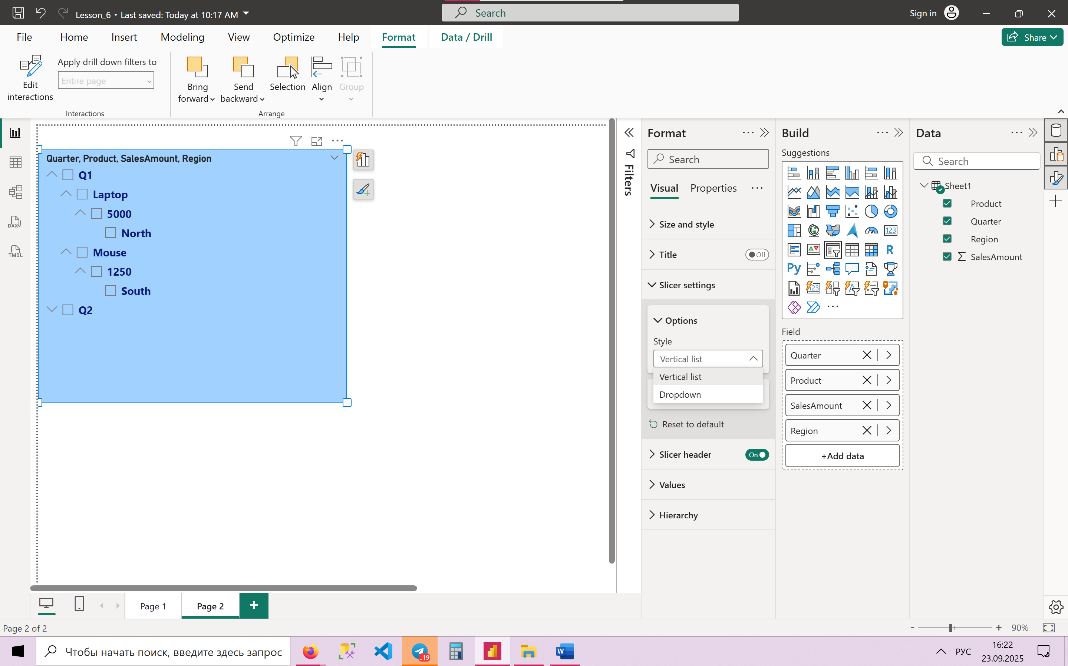

**8. Format the bar chart to show data labels**

* Select the bar chart.
* Go to **Format → Data Labels → On**.

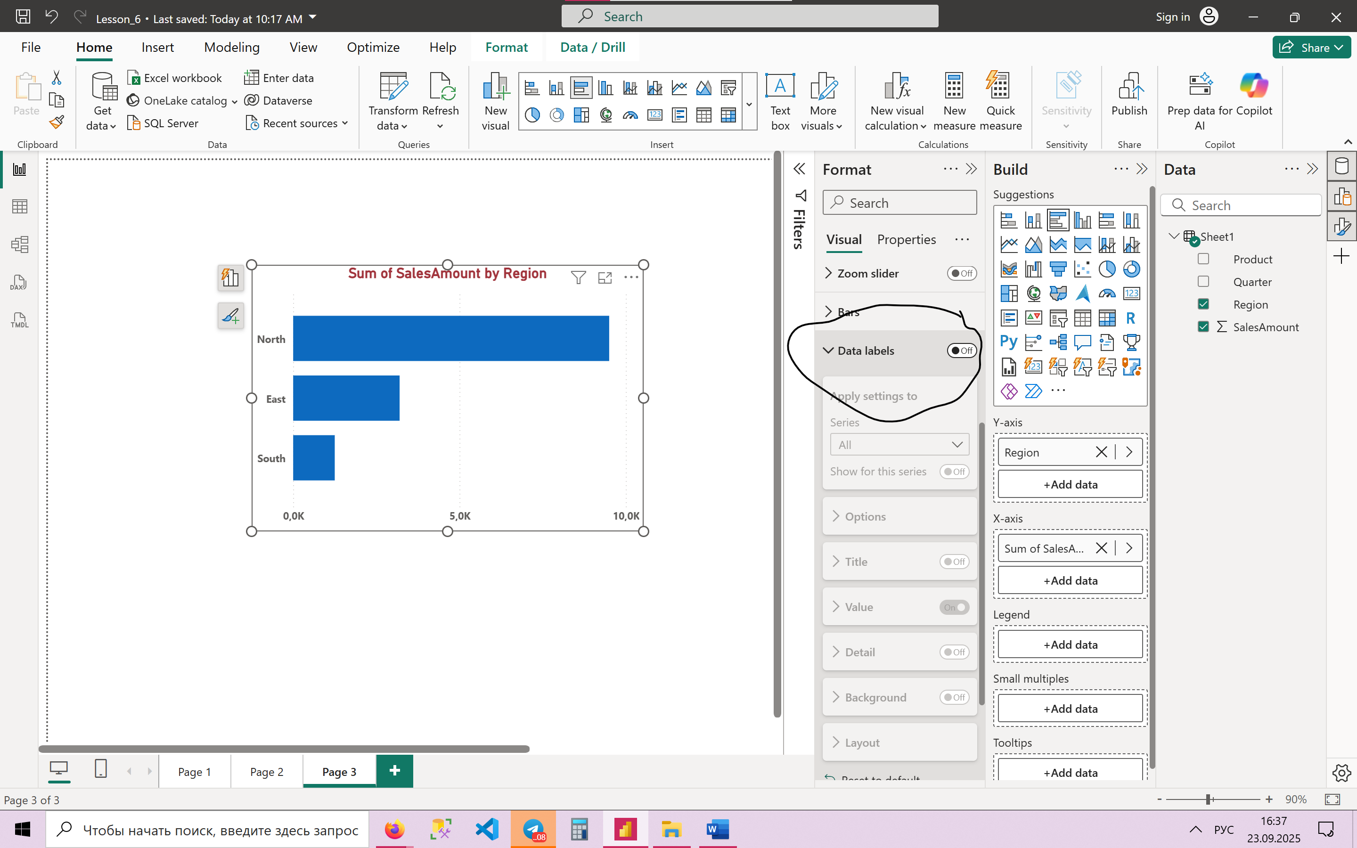

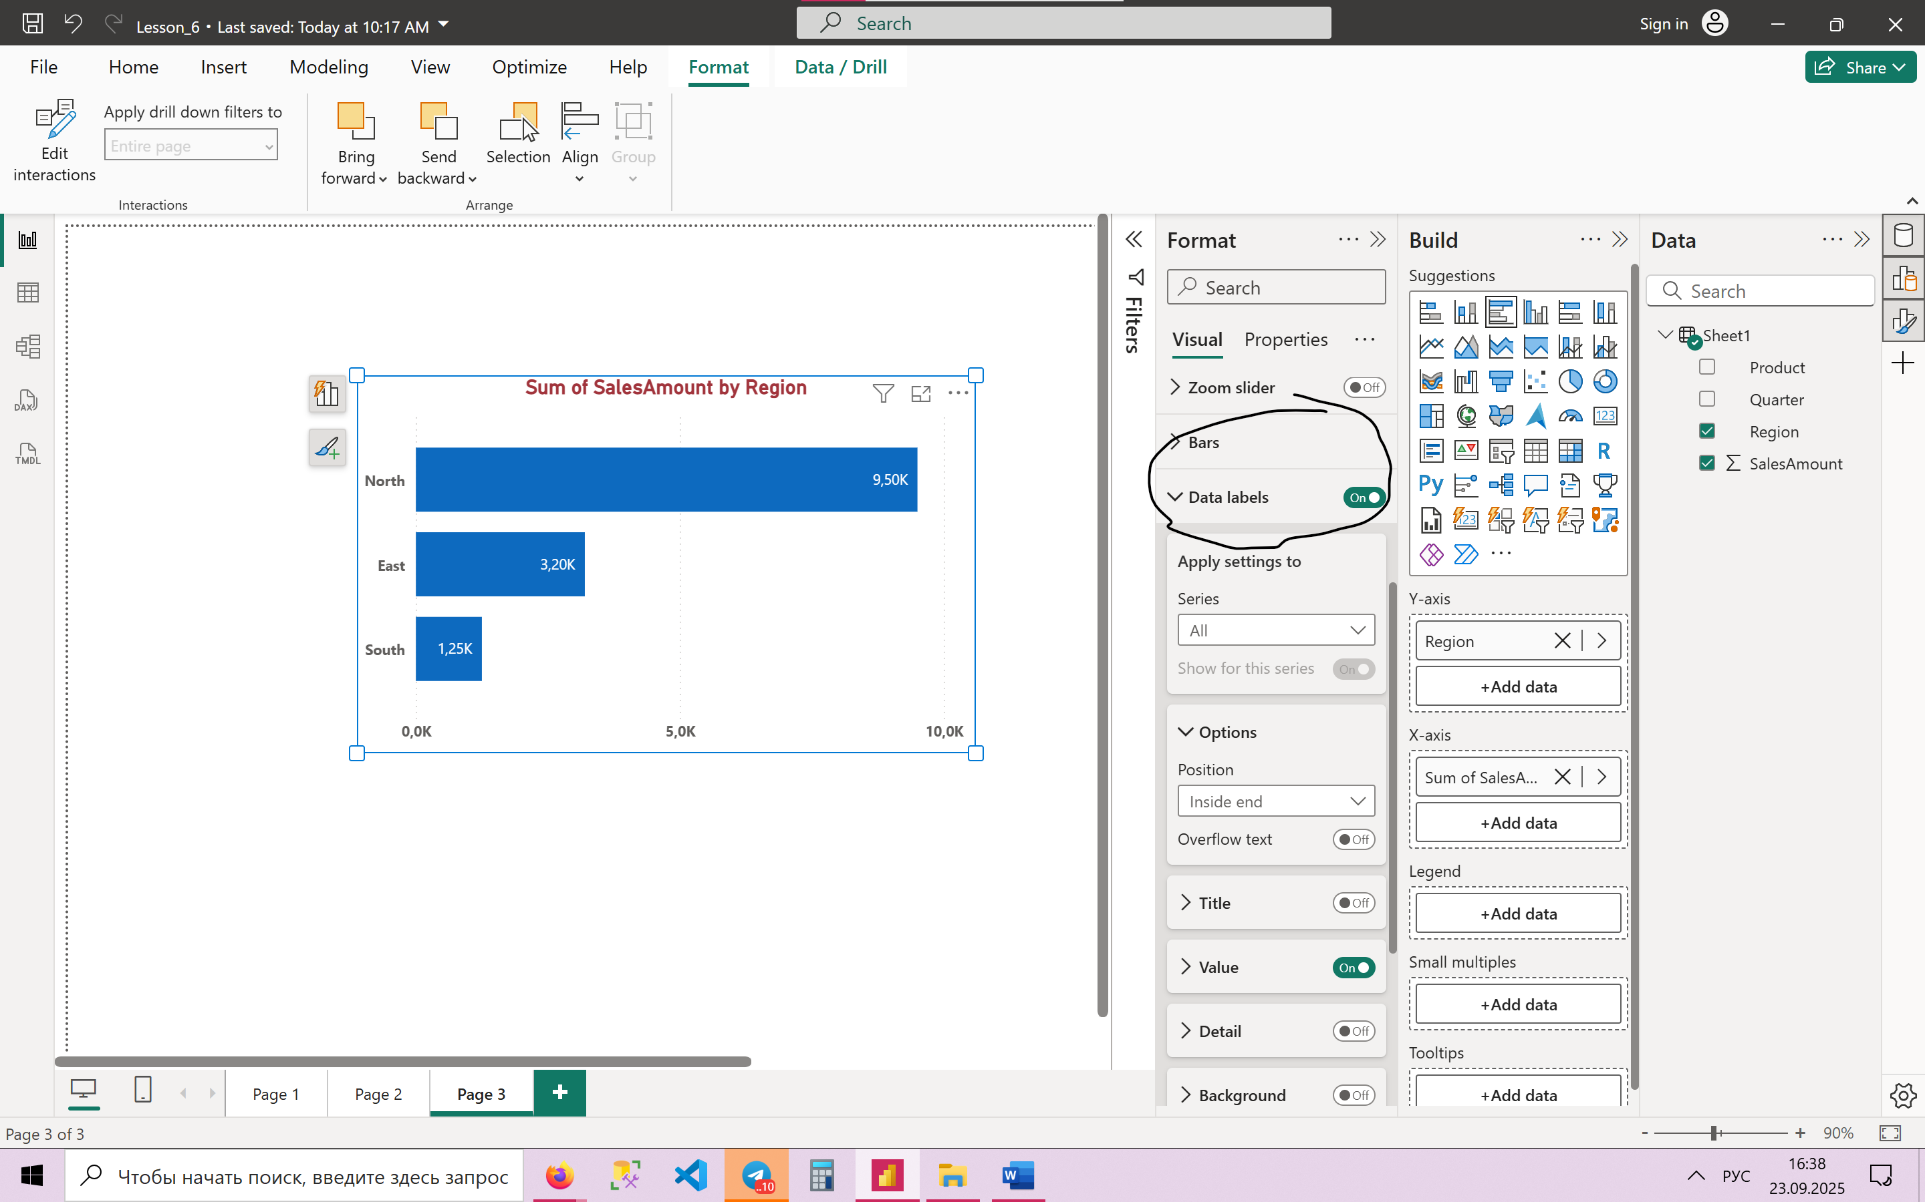

**9. Use a line chart to show SalesAmount trends over Quarter**

* Choose **Line Chart**.
* Place Quarter on the X-axis.
* Place SalesAmount in Values.

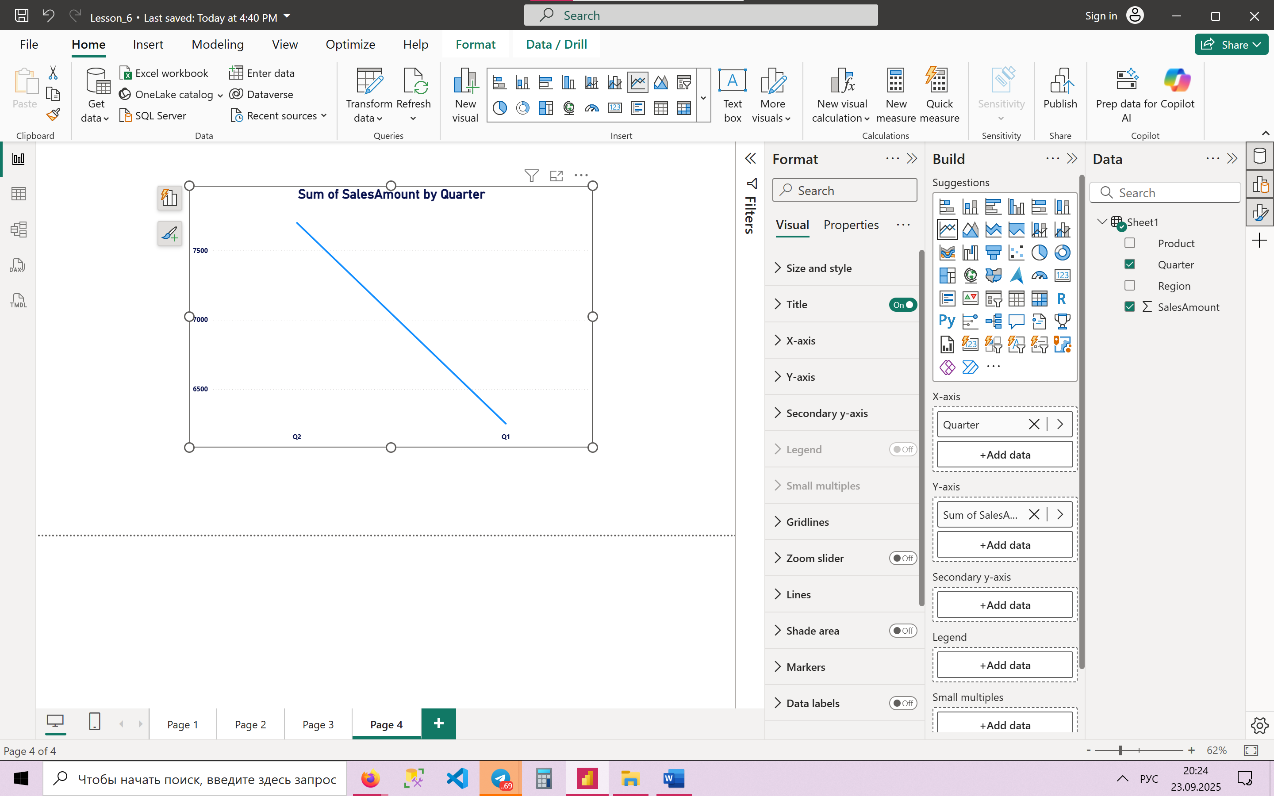

**10. Add a tooltip to display Product details when hovering over bars**

* Select the bar chart.
* In **Fields → Tooltip**, drag Product.
* Then hovering over a bar shows product details.

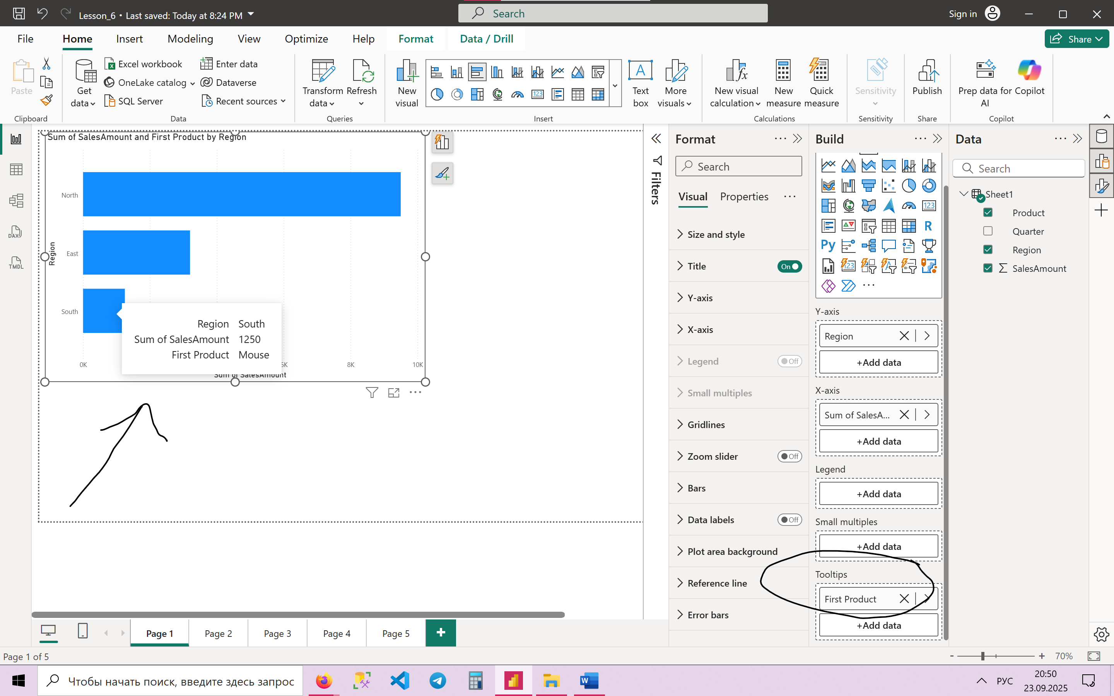

**11. Sync slicers across multiple report pages**

* Add a slicer on the first page.
* Go to **View → Sync Slicers**.
* Select the pages where the slicer should apply.

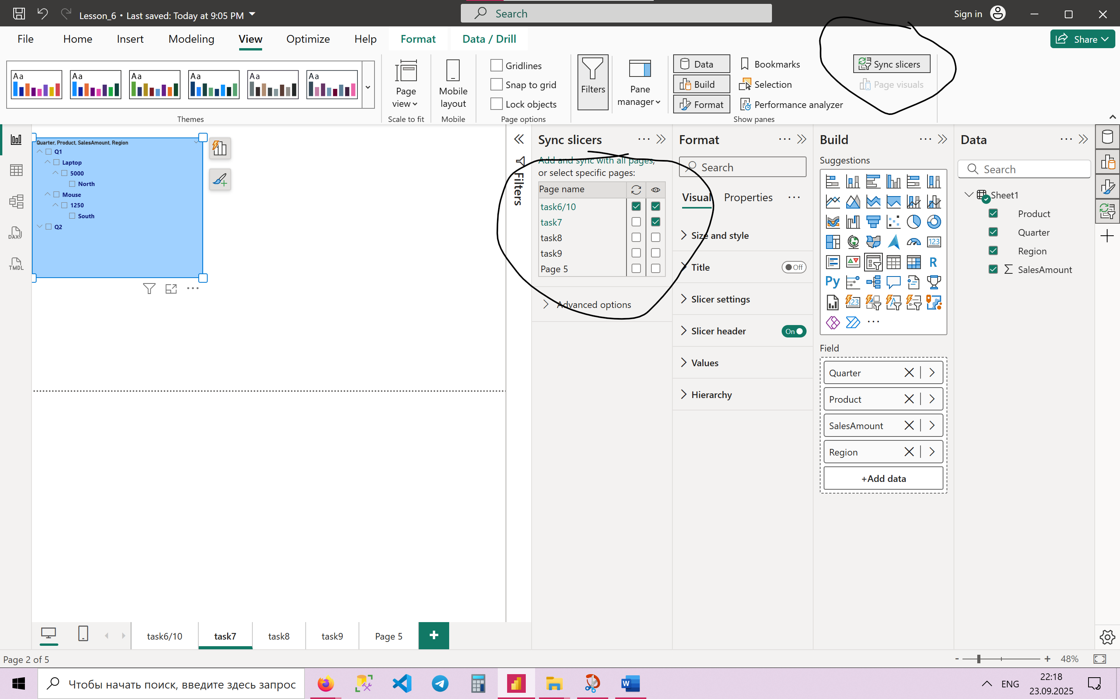

**12. Create a custom visual with dynamic measure selection (Sales vs. Profit)**

* Create measures like *SalesAmount* and *Profit*.
* Use **Field Parameters** or **What-if Parameter** to switch between measures.
* User can toggle between “Sales” and “Profit” dynamically.

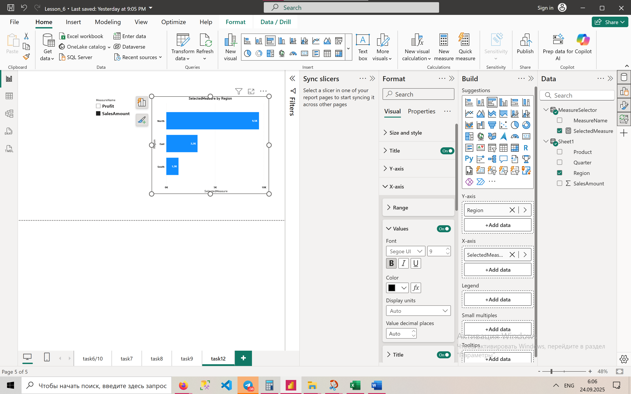

**13. Implement a hierarchy for Region > Product > Quarter drill-down**

* In the Fields pane, drag Region, then Product, then Quarter into one chart.
* Use the **Drill Down** button (arrows on top of the visual) to navigate the hierarchy.

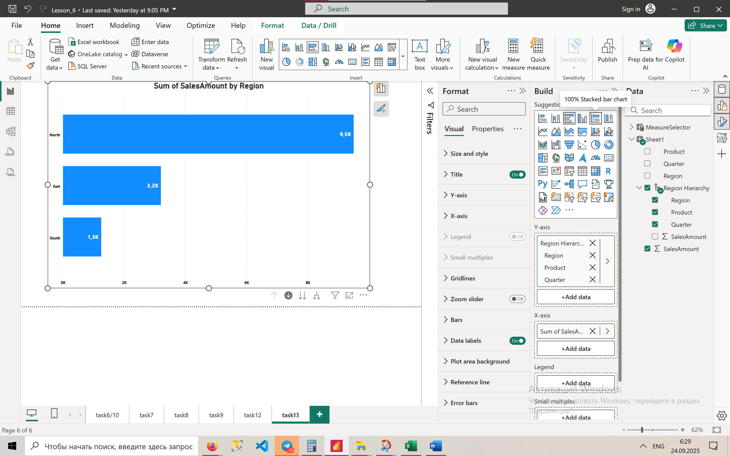

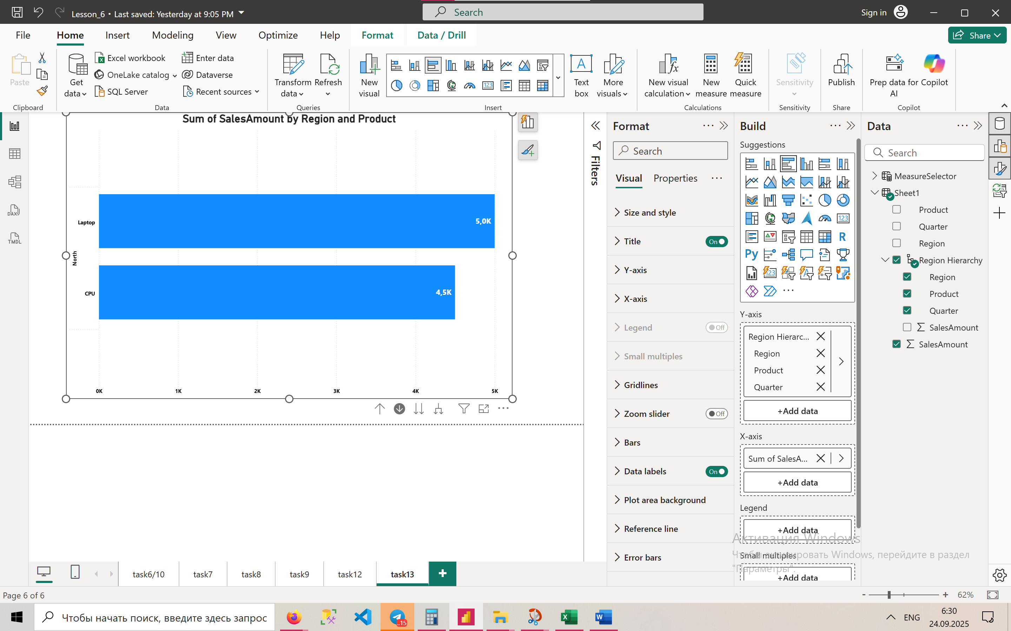

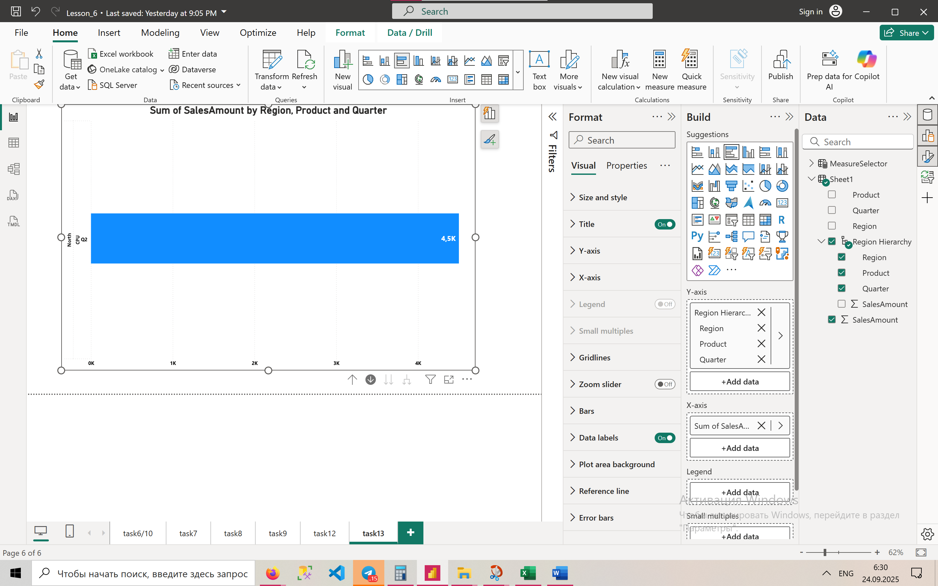

**14. Use bookmarks to toggle between two visuals in the same space**

* Place two visuals (e.g., Column Chart and Line Chart) in the same position.
* Open **View → Selection Pane** and hide one of them.
* Create a **Bookmark** for each view.
* Add a button to toggle between bookmarks.

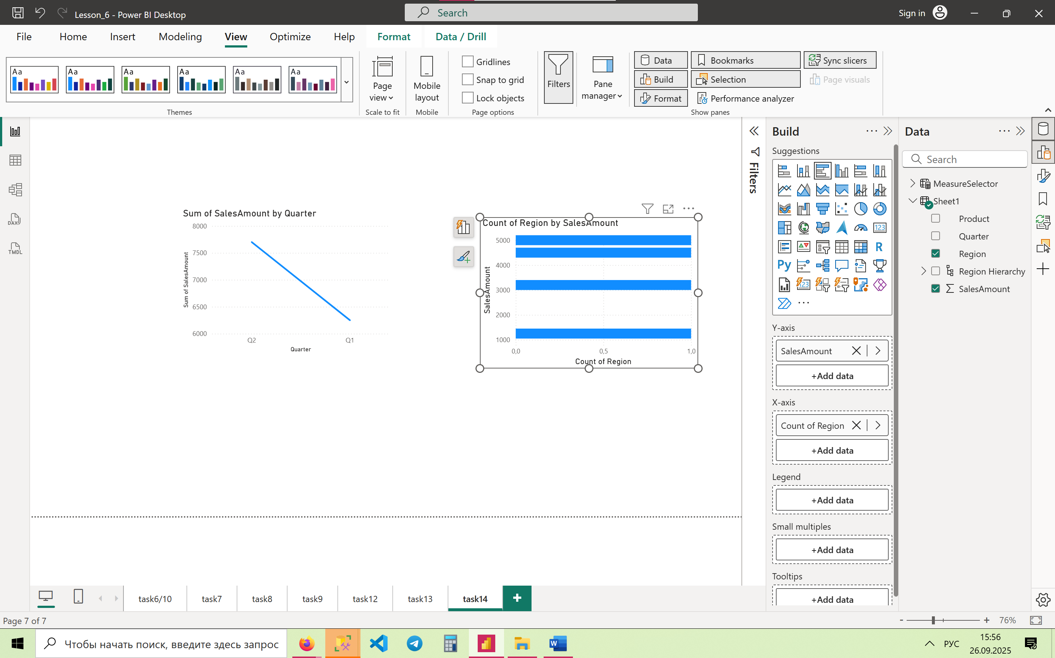

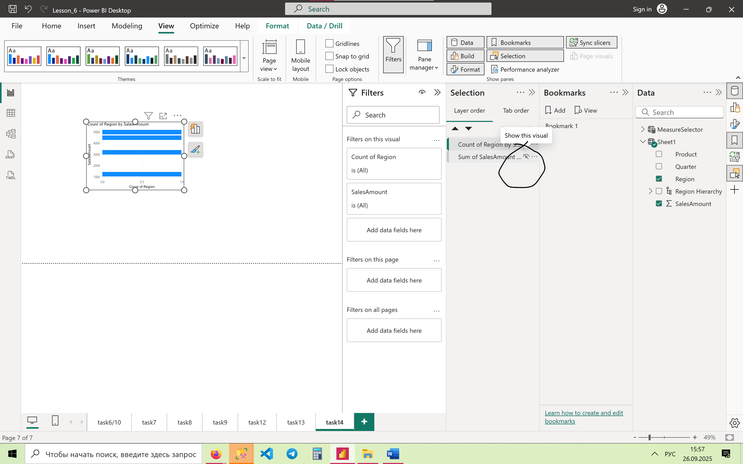

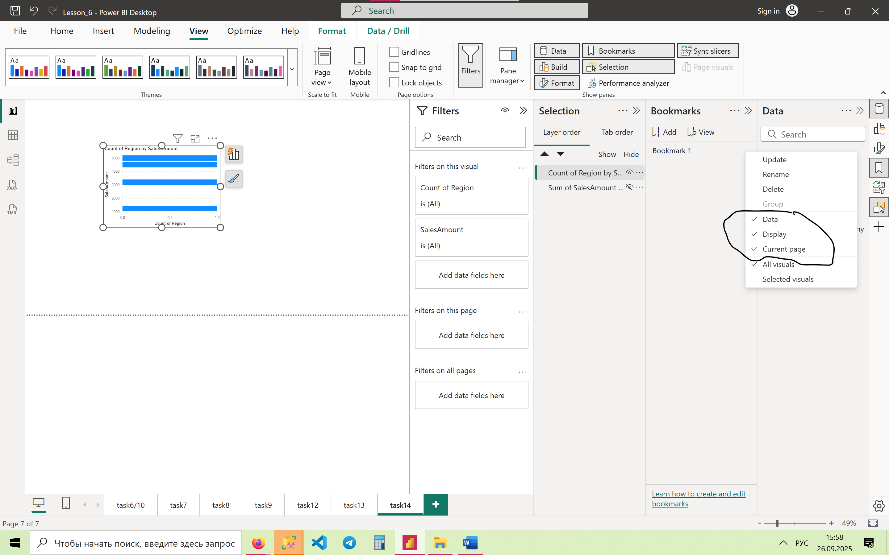

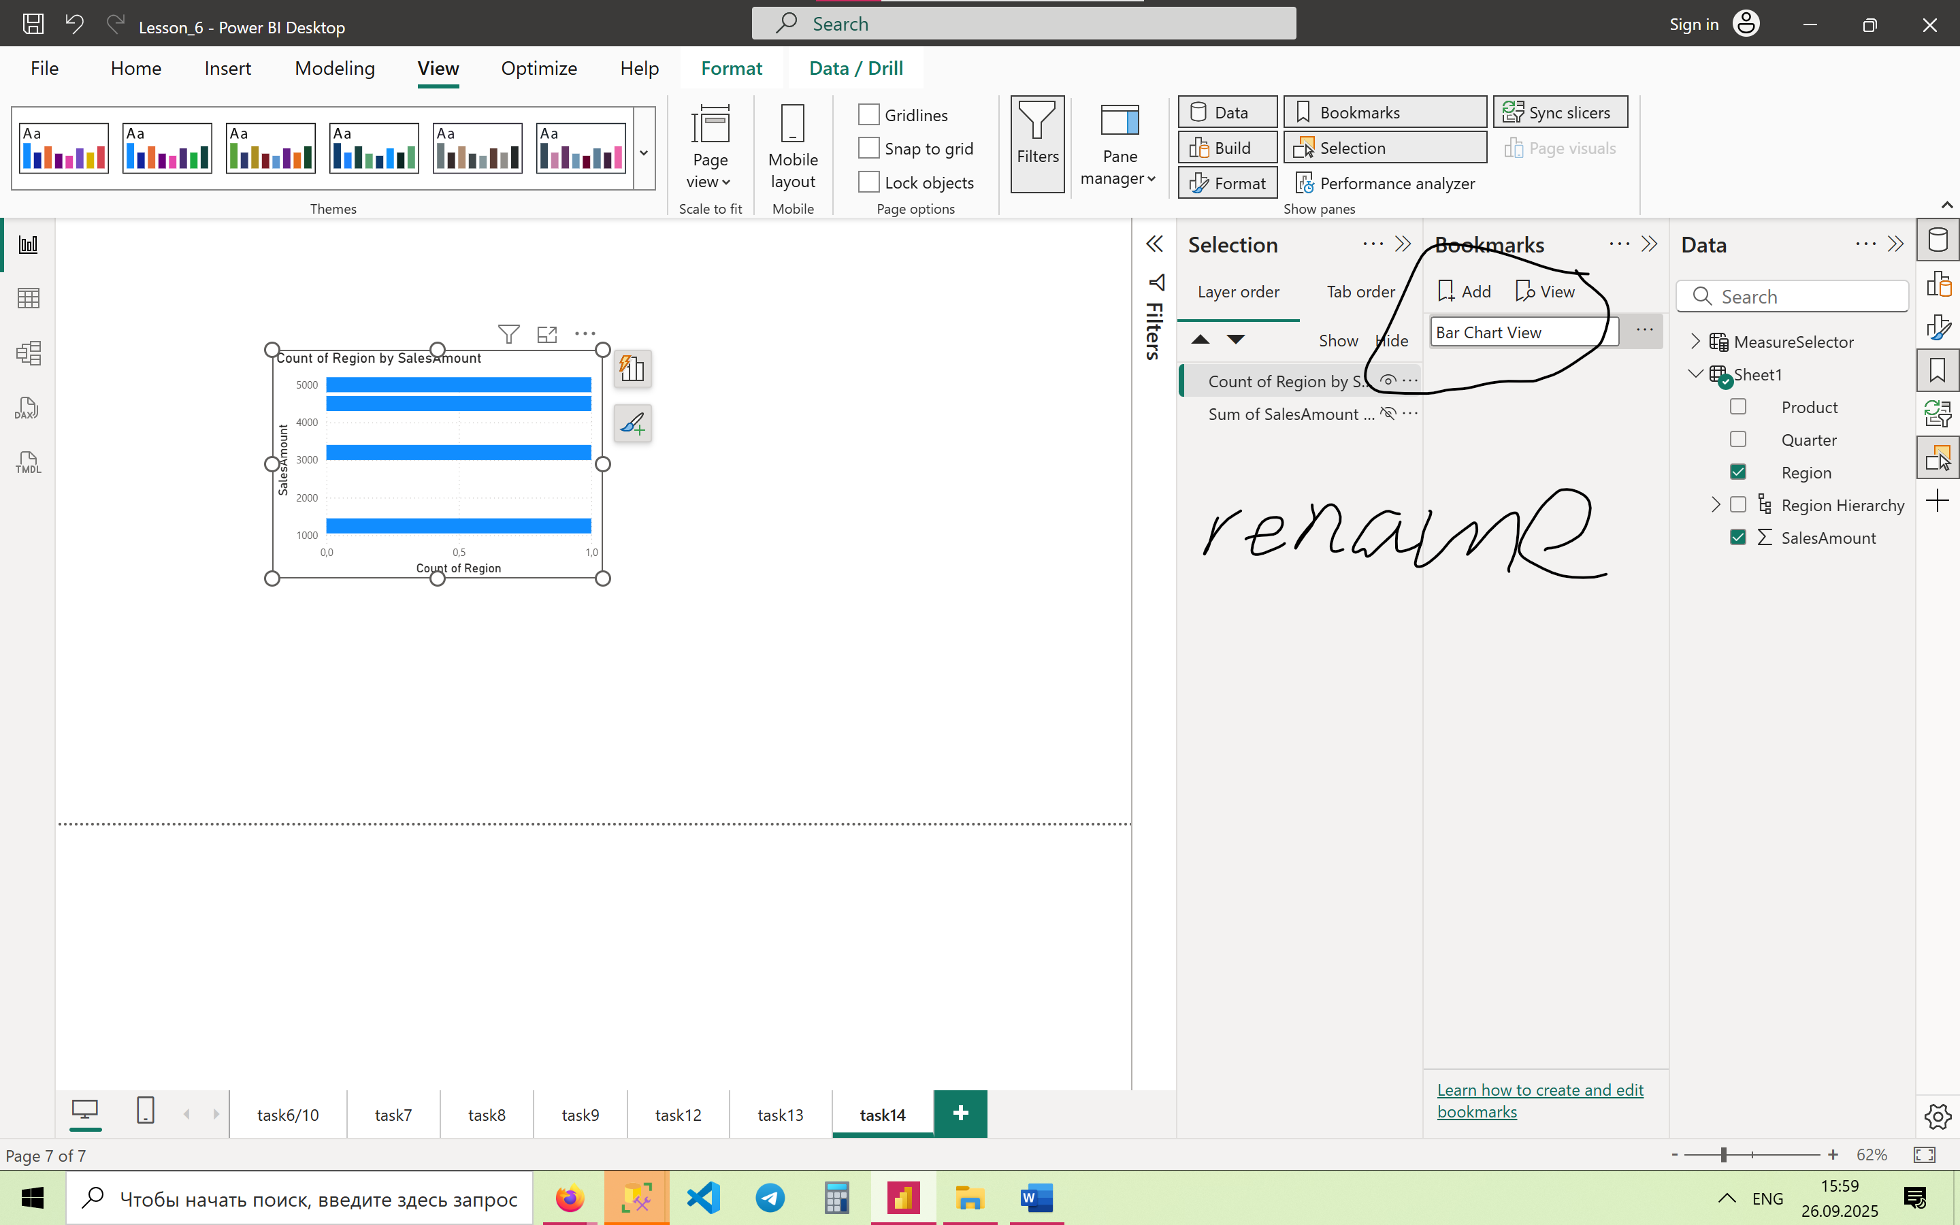

And now we’ll do these processes with the Line Chart:

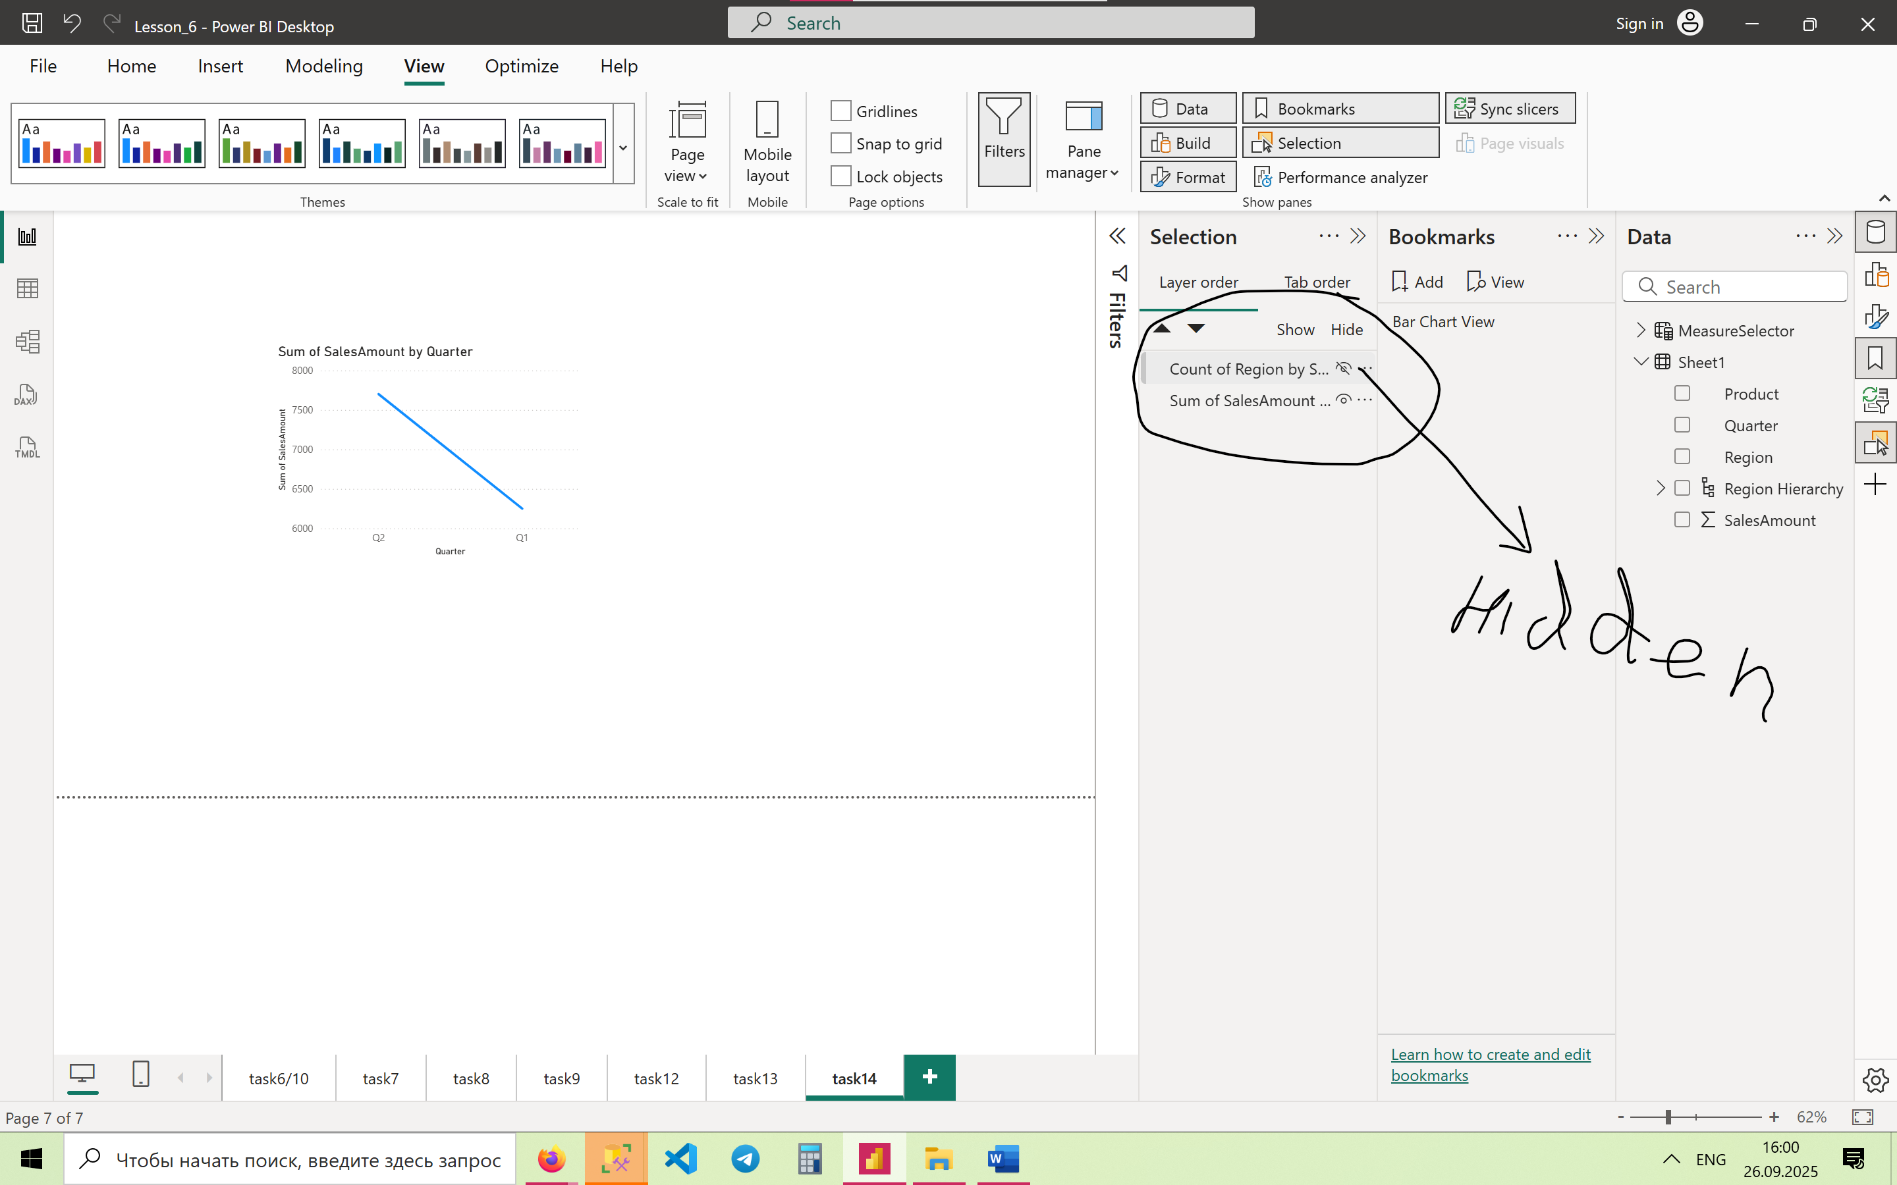

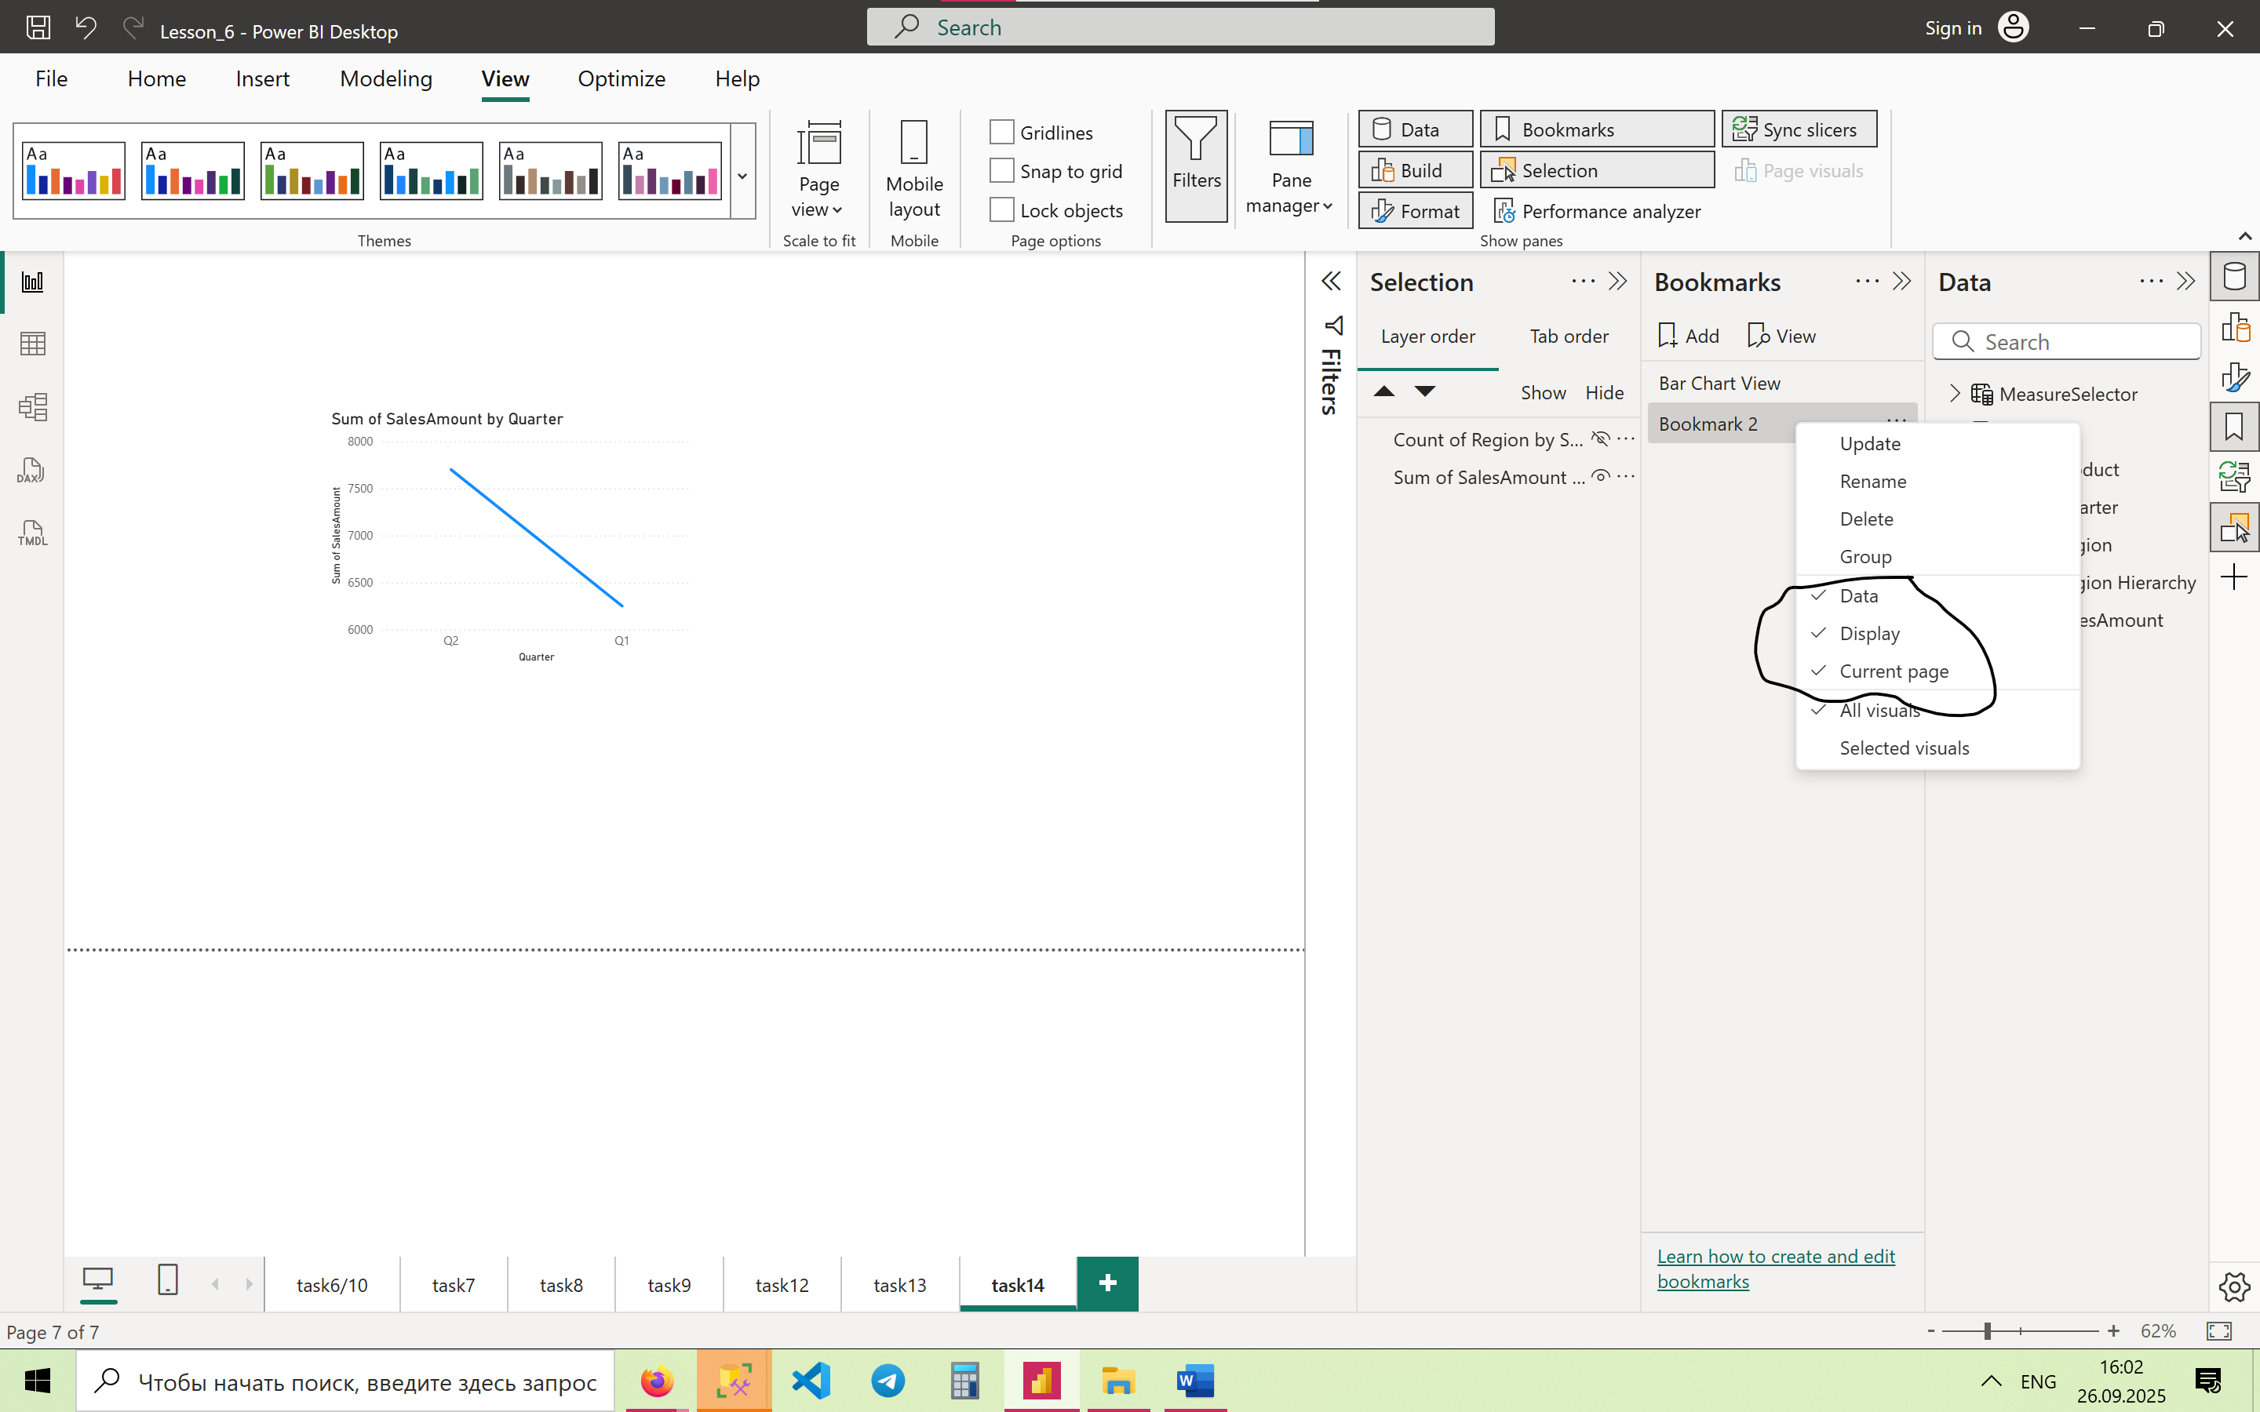

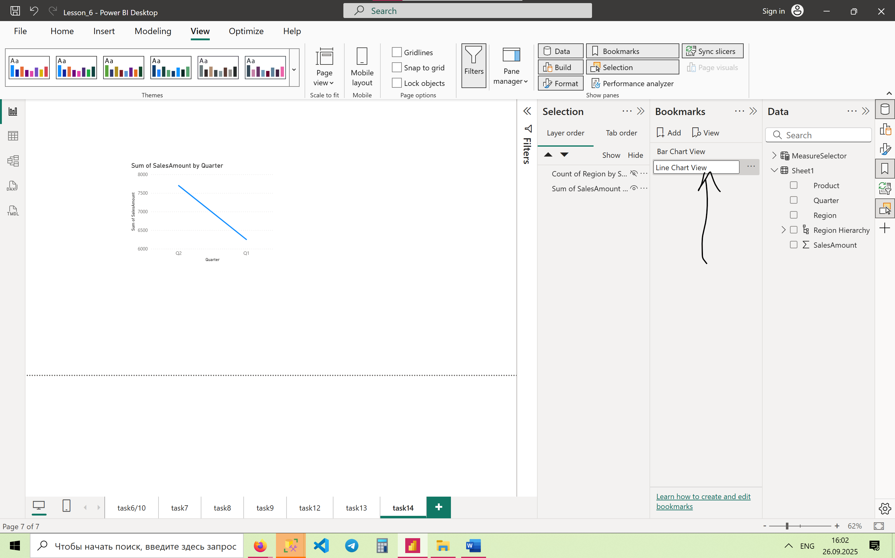

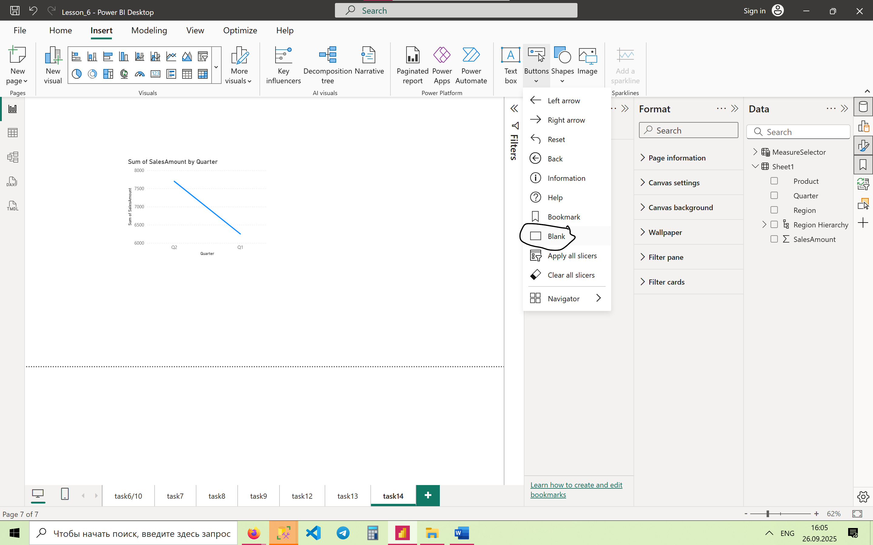

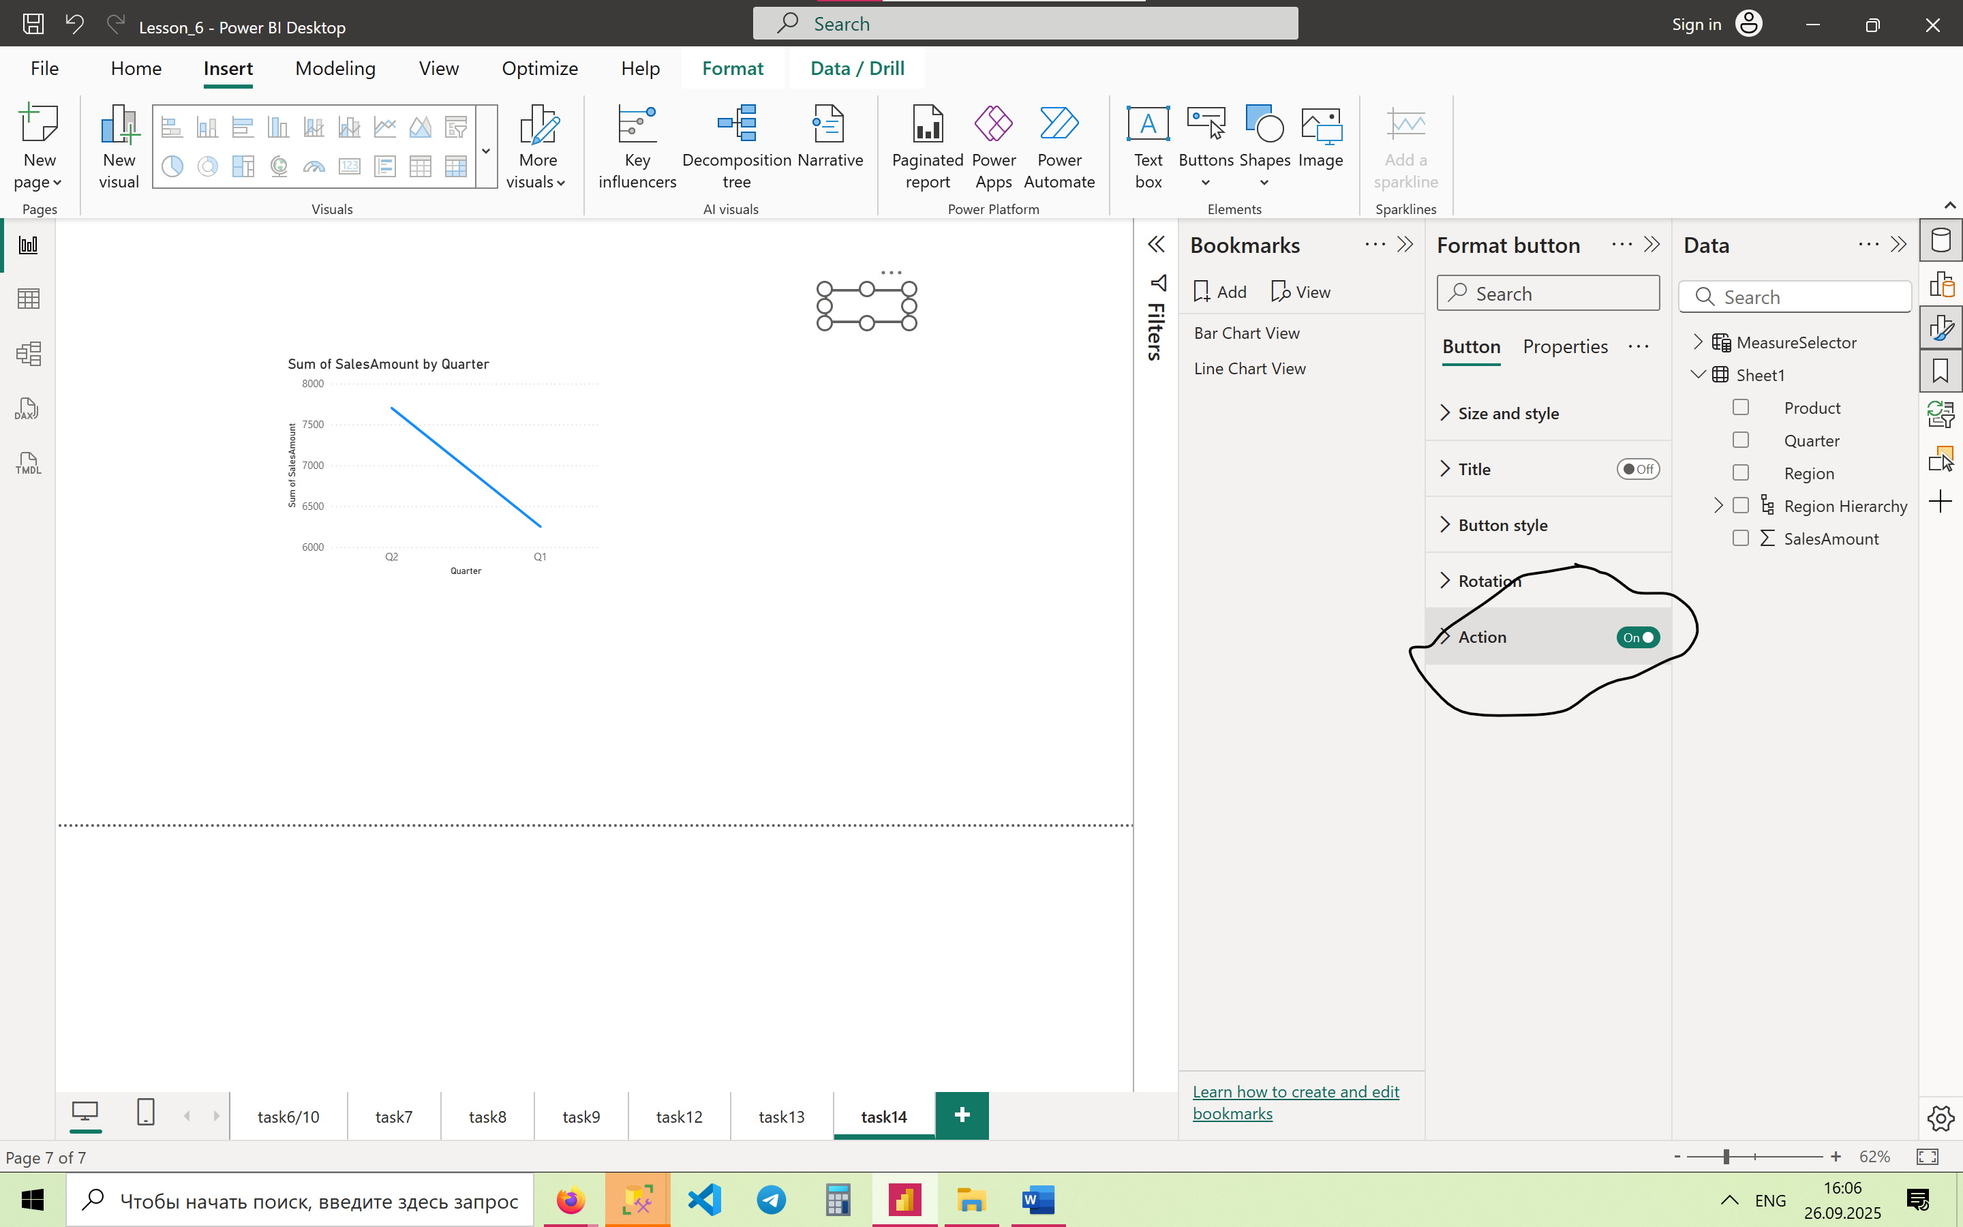

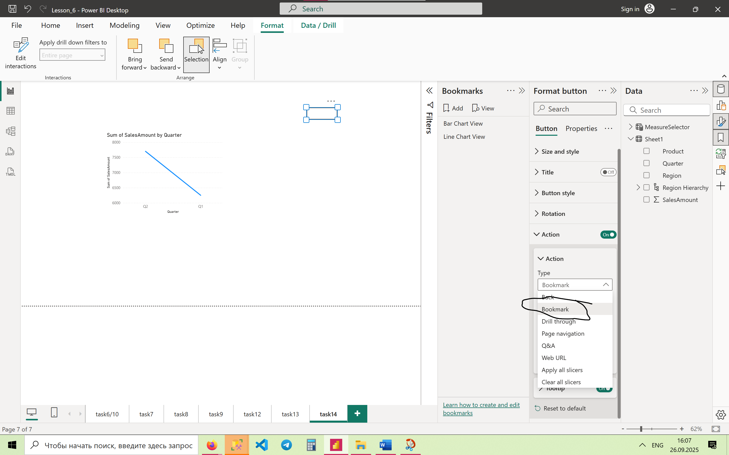

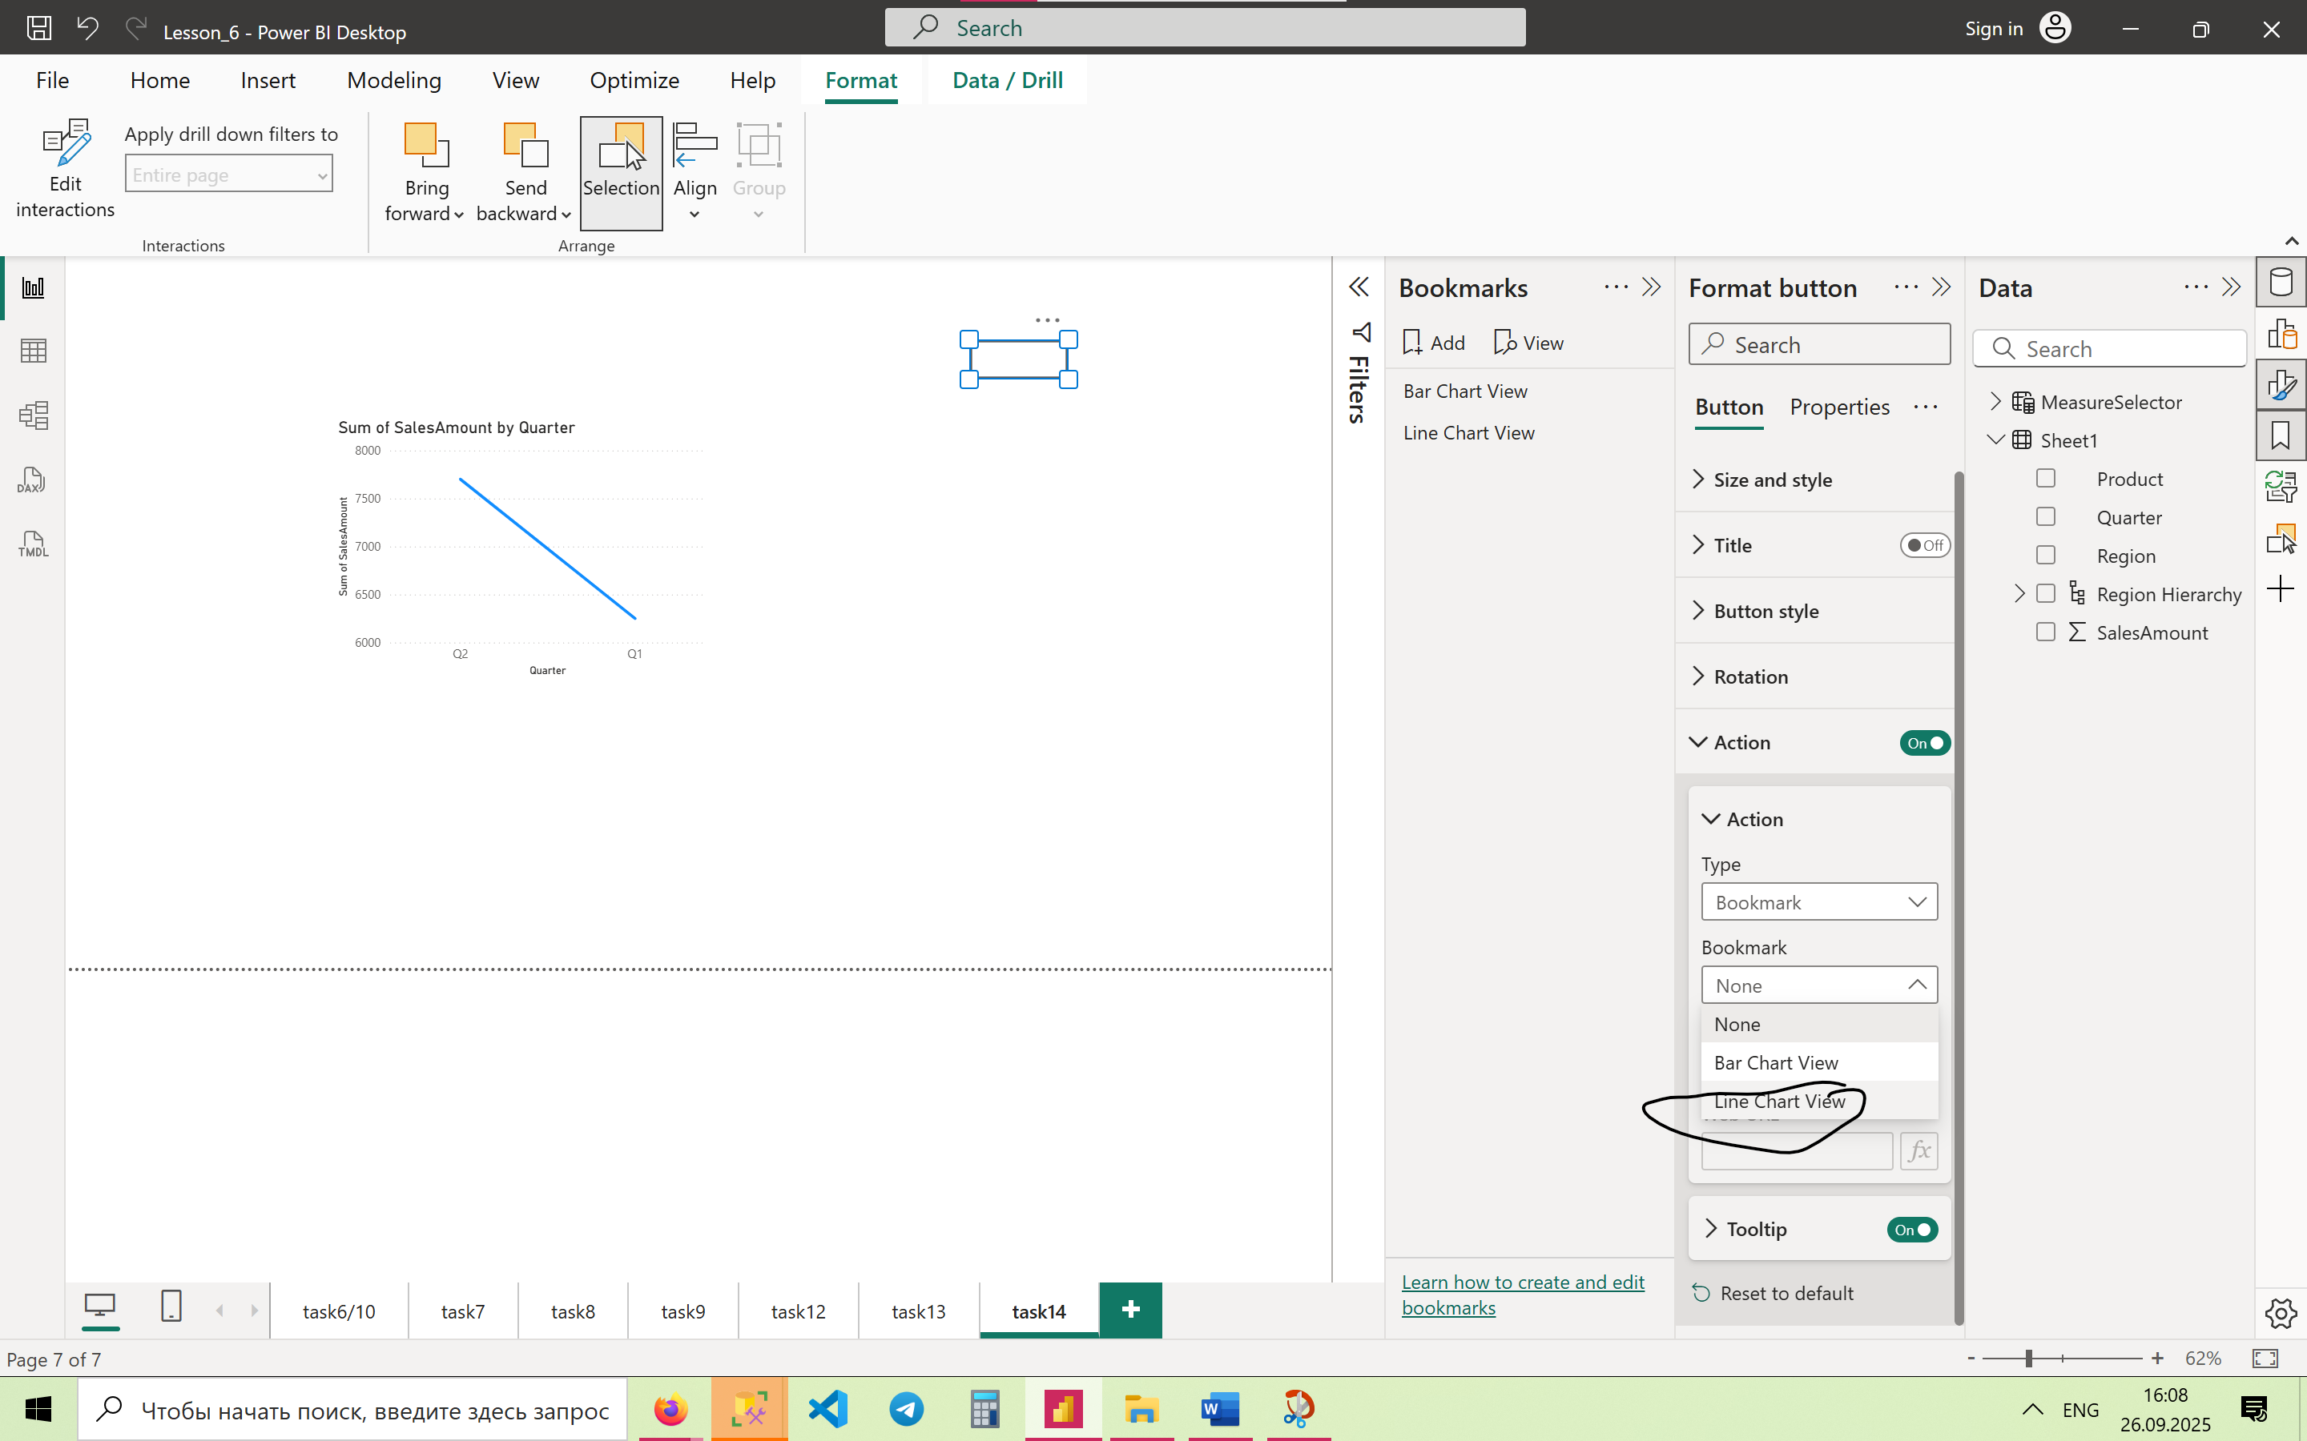

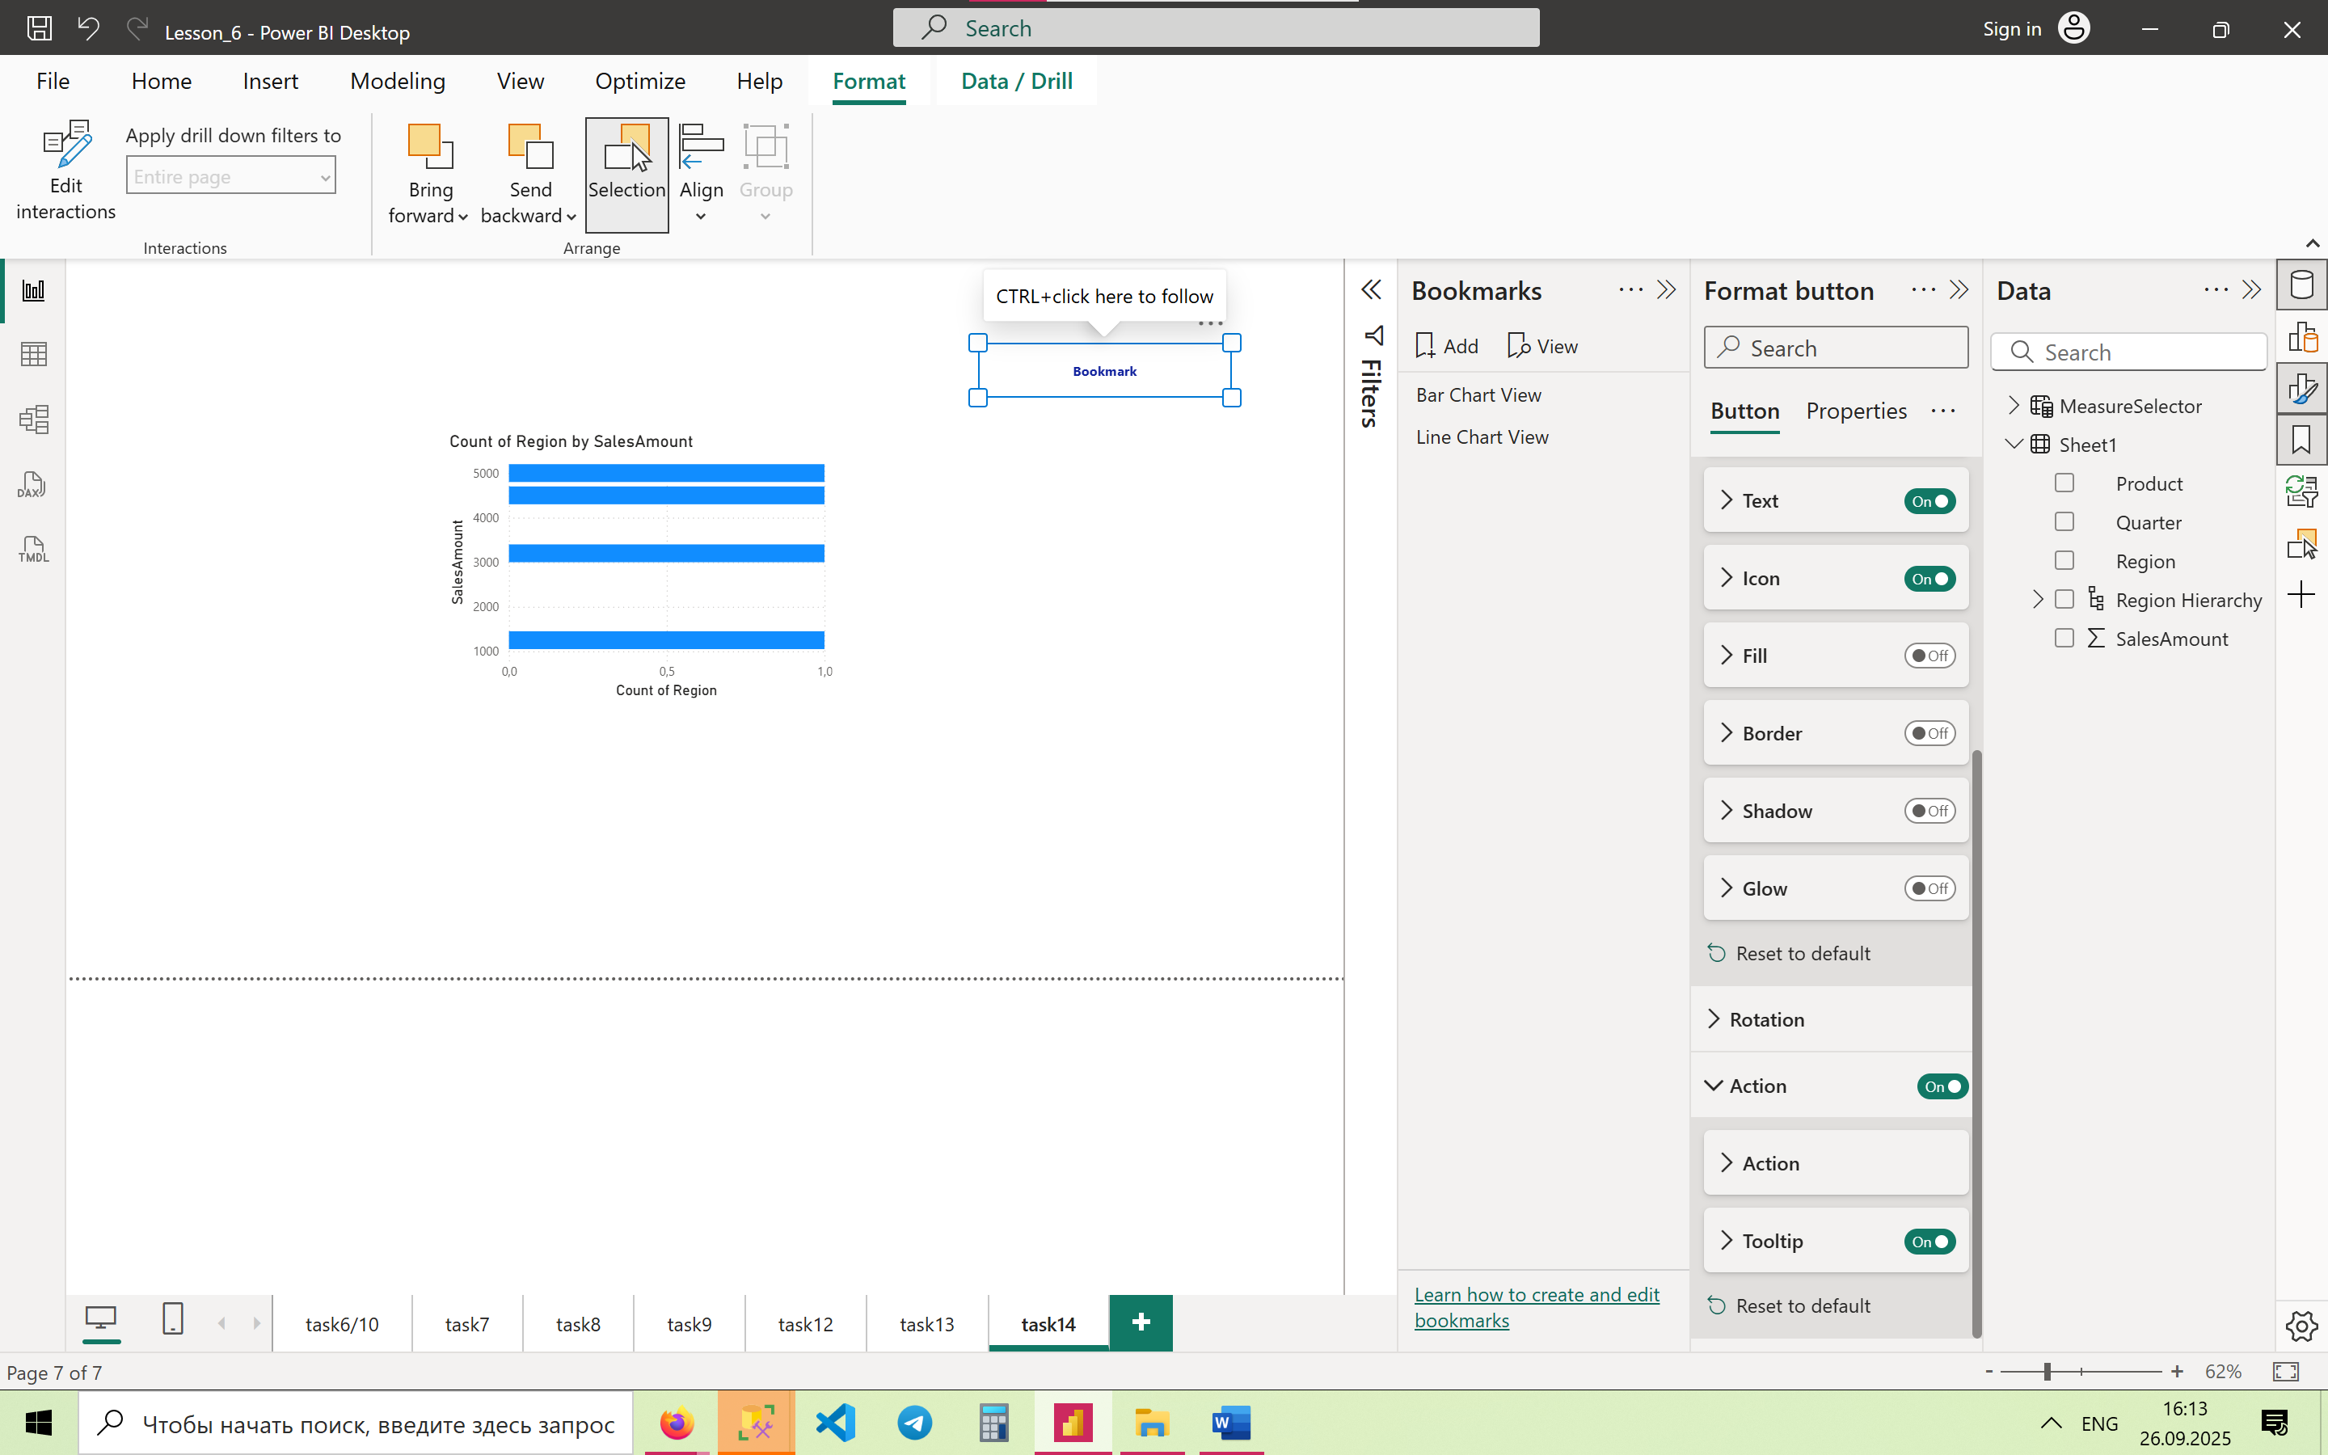

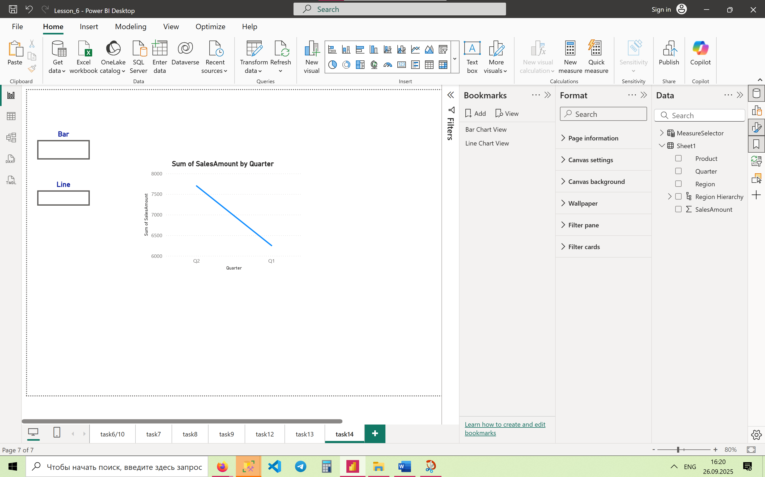

**15. Optimize a slow-rendering report with 10+ visuals**

* Reduce the number of visuals on the page.
* Use **aggregated tables** instead of raw data.
* Use **Performance Analyzer** (View → Performance Analyzer) to check bottlenecks.
* Remove unnecessary fields and filters.

